The code to generate a app with google AI and OpenAI and all other AI will have different implementation, but this helps to generate AI based app with any AI with one single standard code. Without this framework switching to one model to another will be hard. Lang chain generates all the AI based application with four solutions

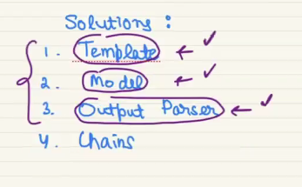

1. Template – Uses to take raw use input
2. Model – takes the converted raw input to correct prompt and this model produced output by selecting correct model.
3. Output – the output from model will not be structured, so this structures the output.
4. Chains - All the above process are separate process we have to put it all together

**TEMPLATING**

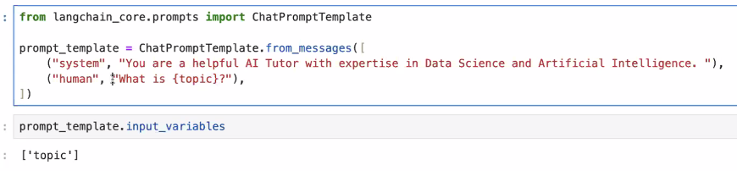

With the placeholder of topic we can give the actual user propmt

**MODEL COMPONENT**

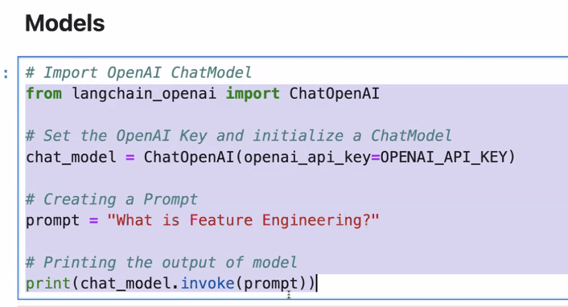

**OUTPUT PARSING:**

There are many output parser available on core

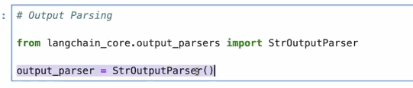

**CHAIN:**

